Think About What You Think

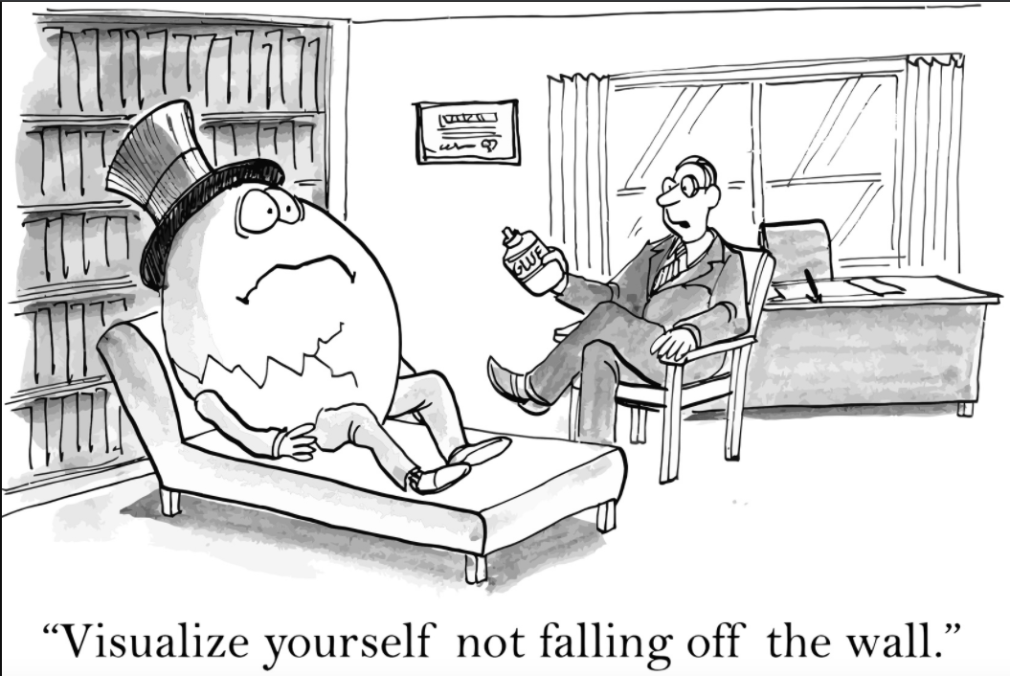
“Always think in terms of solutions. Focusing on the problems usually gives us more of them.” ~ Sam Owen

Food for Thought...
Rather than focusing on solving a problem, solution-focused therapy is designed to help clients focus on uncovering and constructing solutions.
Think about this statement as you watch the video and complete the rest of the assignment. Make sure you follow "the instructions."

The Prompt
Solution-focused therapy (SFT) is a short-term goal-focused, evidence-based therapeutic approach that helps clients construct solutions rather than dwelling on problems. Instead of placing the focus on why or how the problem was created, SFT endeavors to highlight a client’s ability to solve problems. With any presenting client concern, the main technique in SFT is illuminating the exception, which is where things worked well, despite the problem. The therapist guides the client to an area of their life where there is an exception to the problem, and within the exception an approach for a solution is uncovered. Since its initial development in 1984, SFBT has become one of the most widely taught and utilized therapy approaches. It is currently being used in educational settings, business coaching, as well as in counseling, mental health, social service, and addictions treatment settings

The Instructions
- Watch the "What is Solution-Focused Therapy (Solution-Focused Brief Therapy)" video here.
- Referencing the video, your textbook, and other resources discuss the difference(s) you see between SFT and at least one of the other therapeutic approaches in your text.
- Can integrating other approaches be used to create a more effective counseling strategy? How? Why?

Your Assignment Response
- For this assignment, your response should be a minimum of two complete paragraphs.
- The assignment due date is Sunday, Ma

